Project: Hazardous Gass Detection System

Name:-Ankit shukla

Roll no**.-21781A04M1**

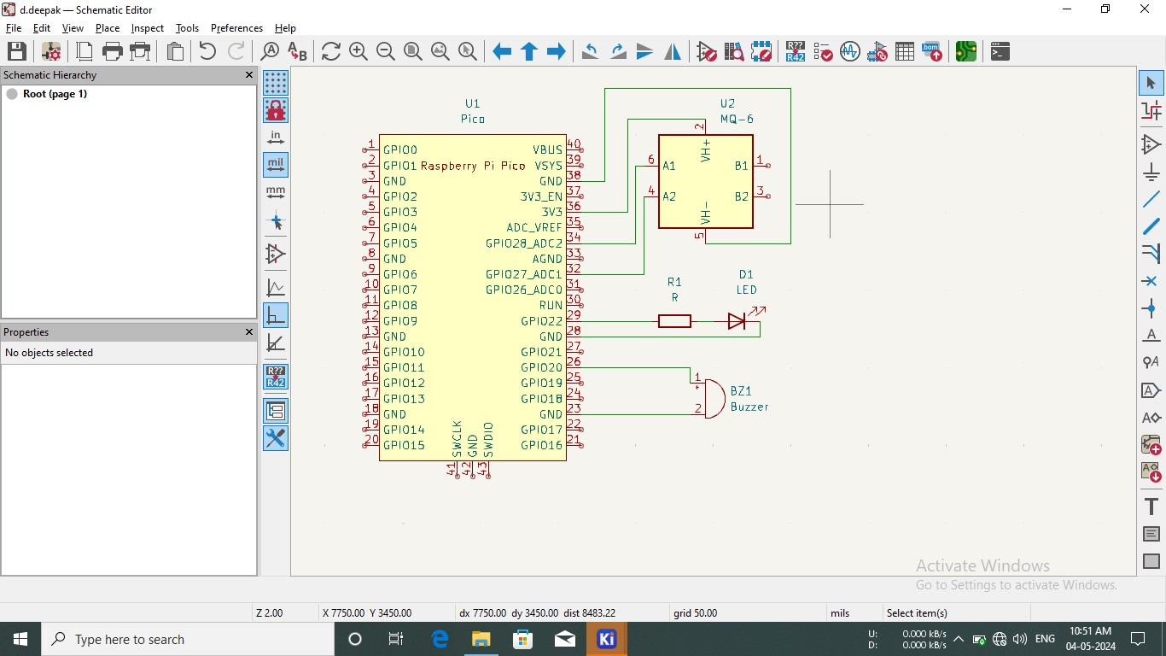

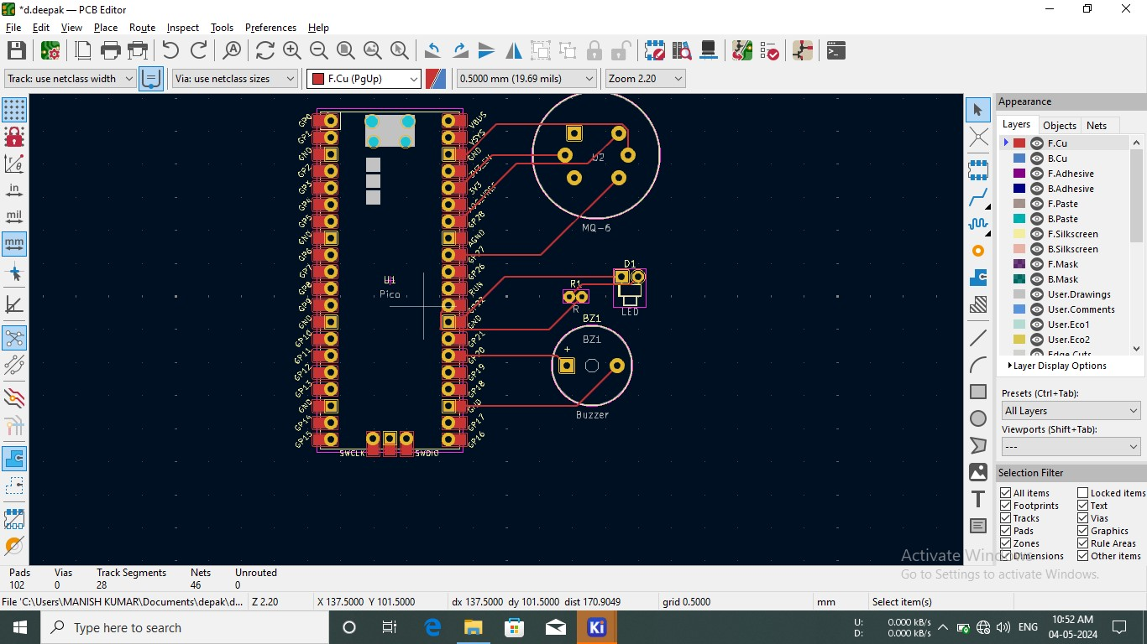

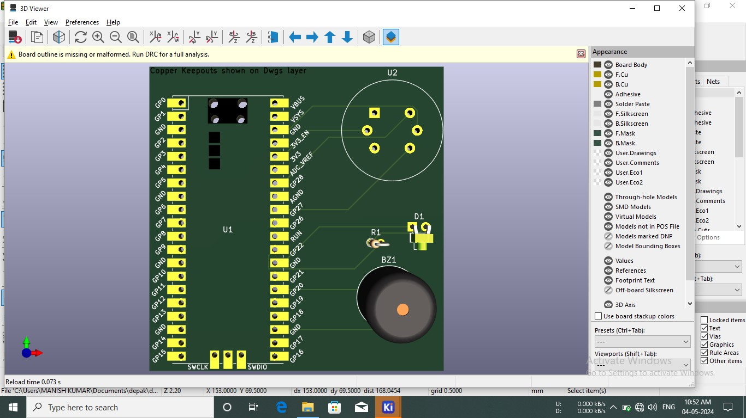

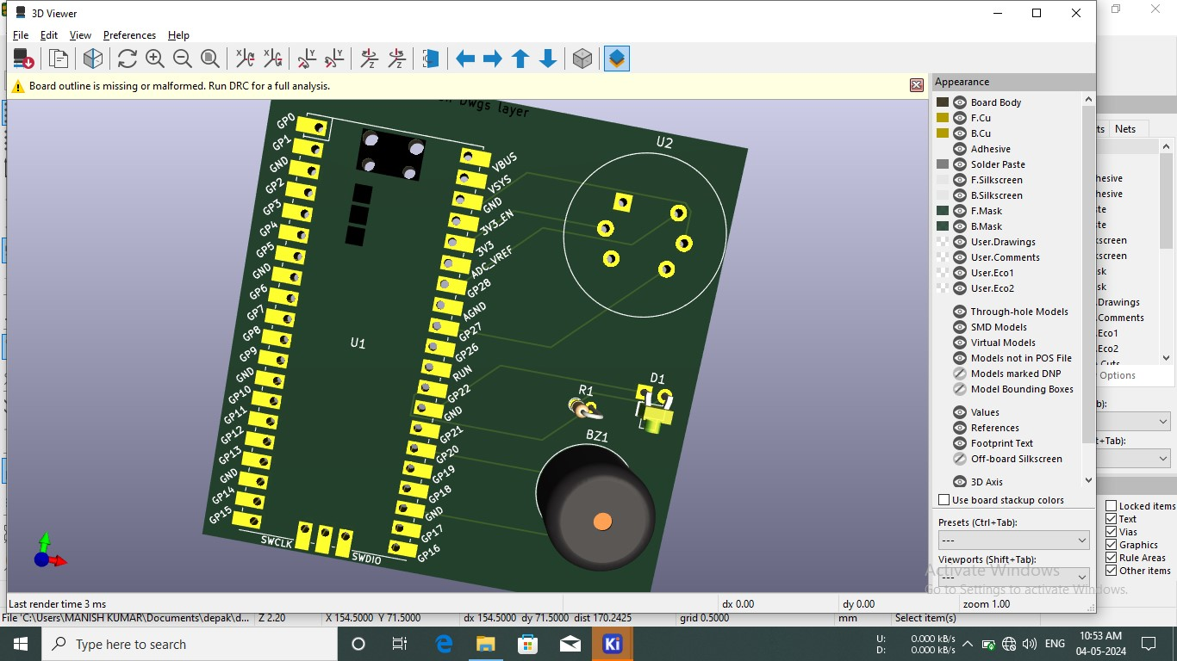

# Project

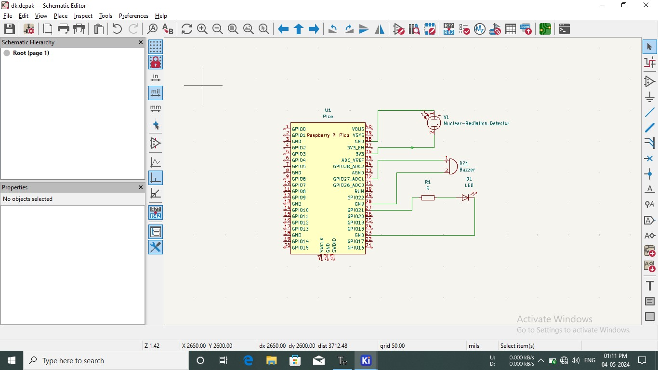

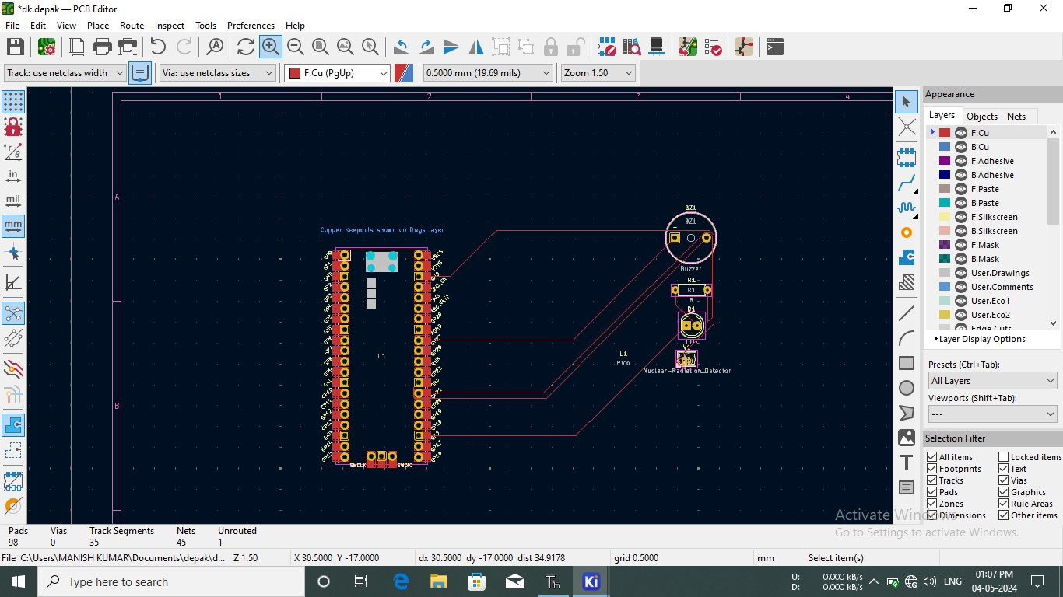

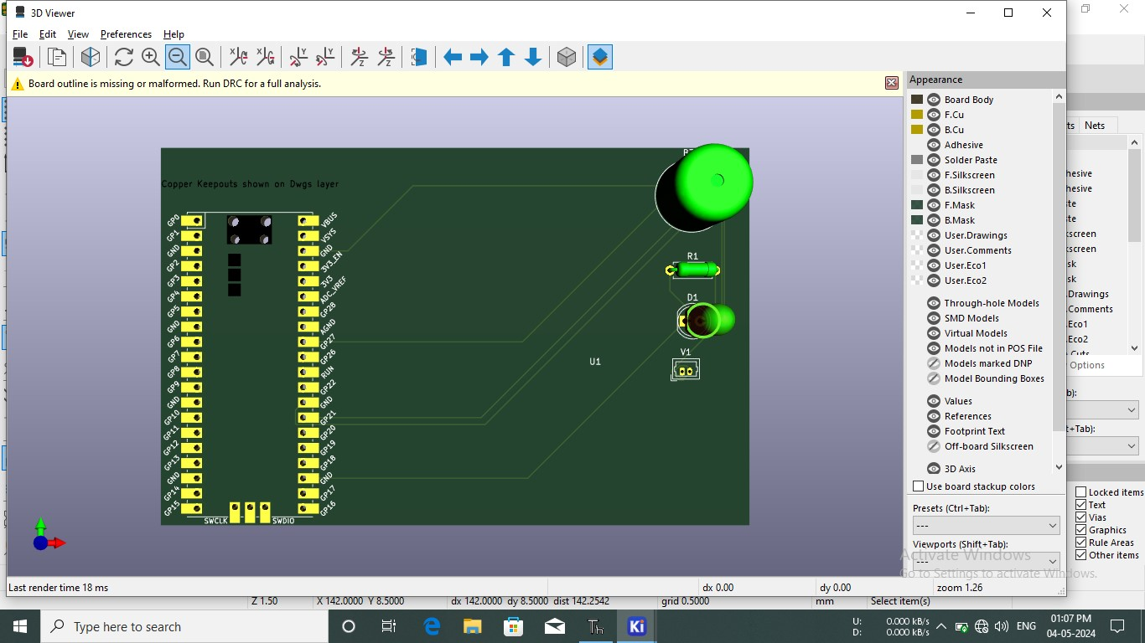

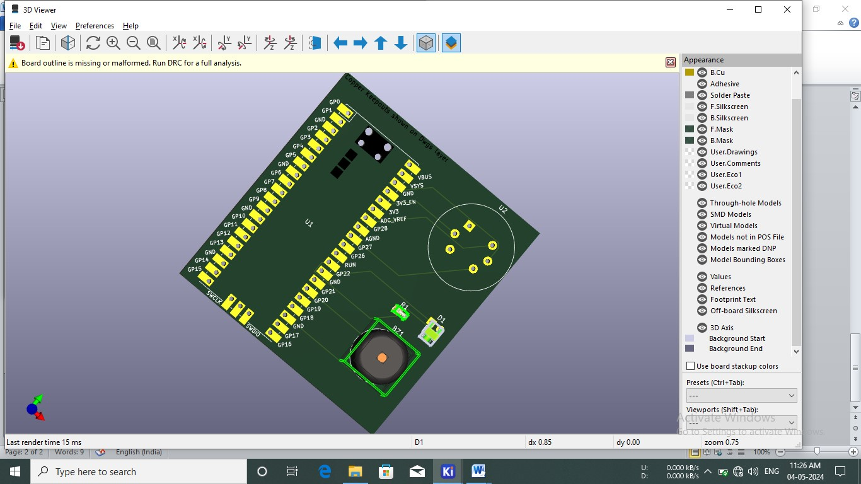

Project:- 3

PROGRAM:-

1. import machine
2. import time

3

1. # Define pin numbers
2. PIR _PIN = machine. Pin (27, machine.Pin.IN)
3. BUZZER _PIN machine. Pin (6, machine.Pin.OUT)

8 # Function to activate the buzzer 9 def activate_buzzer():

1. BUZZER_PIN.on()
2. time.sleep(0.5)
3. BUZZER_PIN.off()
4. 14

15 #mMain loop to detected motion

#Keep buzzer on for 0.5 seconds

#Turn buzzer off

15 Main loop to detect motion 16 while True:

1. if PIR PIN.value(): # PIR sensor detects motion
2. print("Motion detected!")
3. activate_buzzer()
4. time.sleep(0.2)

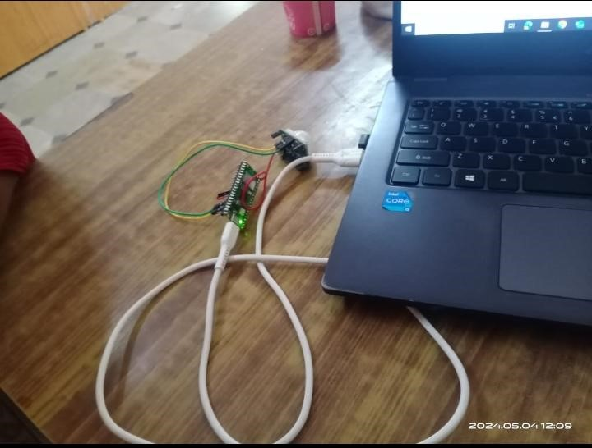

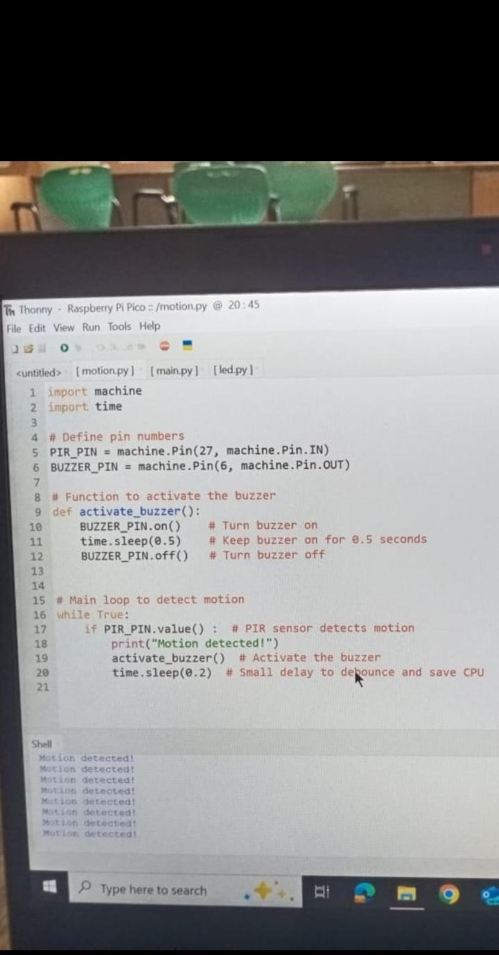

# ***Thank You***